School of Computer Engineering and Technology
PYTHON LAB ASSIGNMENT NO: 7
Problem Statement:
Load the dataset and plot the data using line, bar, scatter plots, and heatmap with Seaborn and Matplotlib library.
Aim:
Write a Python program to load a small CSV dataset and visualize the data using line, bar, scatter, and heatmap plots.
Objectives:
1. To load and explore a CSV dataset using Pandas.
2. To understand the importance of data visualization.
3. To create a line plot using Matplotlib.
4. To create a bar plot using Matplotlib.
5. To create a scatter plot using Matplotlib.
6. To create a heatmap using Seaborn.
Theory:
1. What is data visualization?
2. What is the purpose of a line plot?
3. What is the purpose of a bar plot?
4. What is a scatter plot used for?
5. What is a heatmap?
6. What is correlation?
7. What are Matplotlib and Seaborn?
Platform:
Windows/Ubuntu - Jupyter Notebook (Python 3).
Required Libraries:
Pandas, Matplotlib, and Seaborn.
Dataset:
File name: sample_data_assignment_07.csv
The dataset contains the following columns:
• Student – name of the student
• Maths – Maths marks
• Python – Python marks
• Attendance – attendance percentage
• City – city of the student
Sample Data:
Student | Maths | Python | Attendance | City
Amit | 75 | 80 | 85 | Pune
Bhavna | 82 | 78 | 90 | Mumbai
Chetan | 68 | 70 | 78 | Pune
Diya | 90 | 92 | 95 | Nashik
Esha | 72 | 75 | 80 | Mumbai
Farhan | 85 | 88 | 92 | Pune
Algorithm / Pseudocode:
1. Start.
2. Import Pandas, Matplotlib, and Seaborn.
3. Load the CSV file using pd.read_csv().
4. Display the dataset.
5. Create a line plot of Python marks.
6. Create a bar plot of Maths marks.
7. Create a scatter plot of Maths versus Python marks.
8. Calculate the correlation matrix for Maths, Python, and Attendance.
9. Create a heatmap of the correlation matrix using Seaborn.
10. Display all plots with suitable titles and axis labels.
11. Stop.
Jupyter Notebook Solution:
import pandas as pd
import matplotlib.pyplot as plt
import seaborn as sns

df = pd.read_csv("sample_data_assignment_07.csv")
print(df)

# Line Plot
plt.figure(figsize=(7, 4.5))
plt.plot(df["Student"], df["Python"], marker="o")
plt.title("Python Marks of Students")
plt.xlabel("Student")
plt.ylabel("Python Marks")
plt.grid(True)
plt.show()

# Bar Plot
plt.figure(figsize=(7, 4.5))
plt.bar(df["Student"], df["Maths"])
plt.title("Maths Marks of Students")
plt.xlabel("Student")
plt.ylabel("Maths Marks")
plt.show()

# Scatter Plot
plt.figure(figsize=(7, 4.5))
plt.scatter(df["Maths"], df["Python"], s=70)
plt.title("Maths vs Python Marks")
plt.xlabel("Maths Marks")
plt.ylabel("Python Marks")
plt.grid(True)
plt.show()

# Correlation and Heatmap
correlation = df[["Maths", "Python", "Attendance"]].corr()
print("Correlation Matrix:")
print(correlation)

plt.figure(figsize=(6.5, 5))
sns.heatmap(correlation, annot=True, cmap="Blues", vmin=-1, vmax=1)
plt.title("Correlation Heatmap")
plt.show()
Expected Outputs:
1. Line Plot – Python marks for each student.
2. Bar Plot – Maths marks for each student.
3. Scatter Plot – relationship between Maths and Python marks.
4. Heatmap – correlation among Maths, Python, and Attendance.
Output – Line Plot:
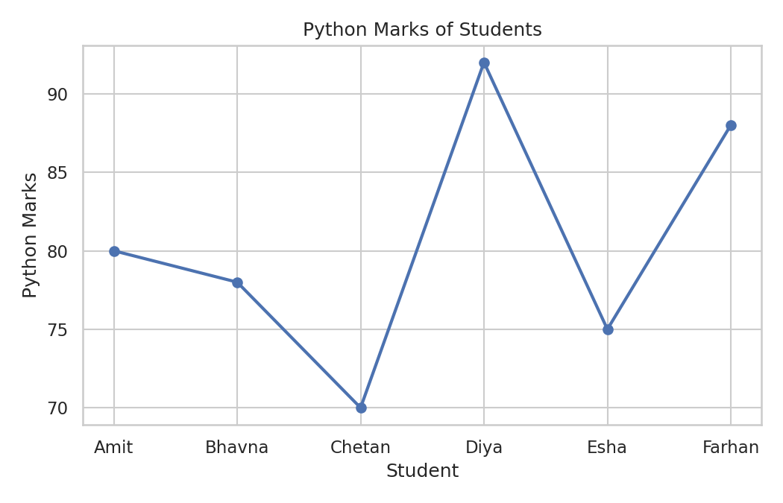
Output – Bar Plot:
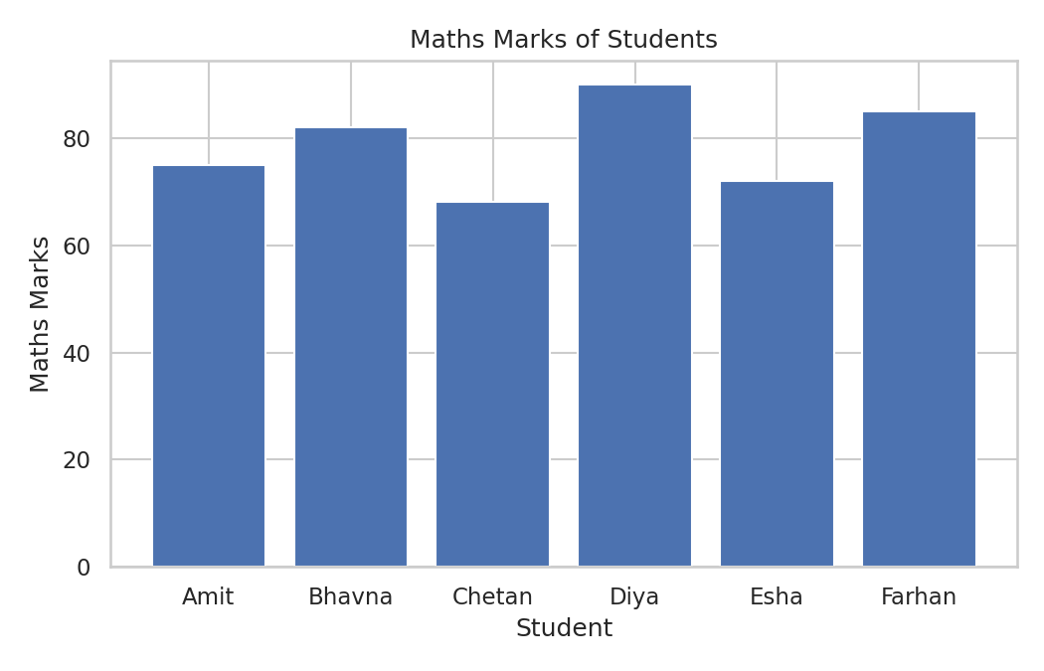
Output – Scatter Plot:
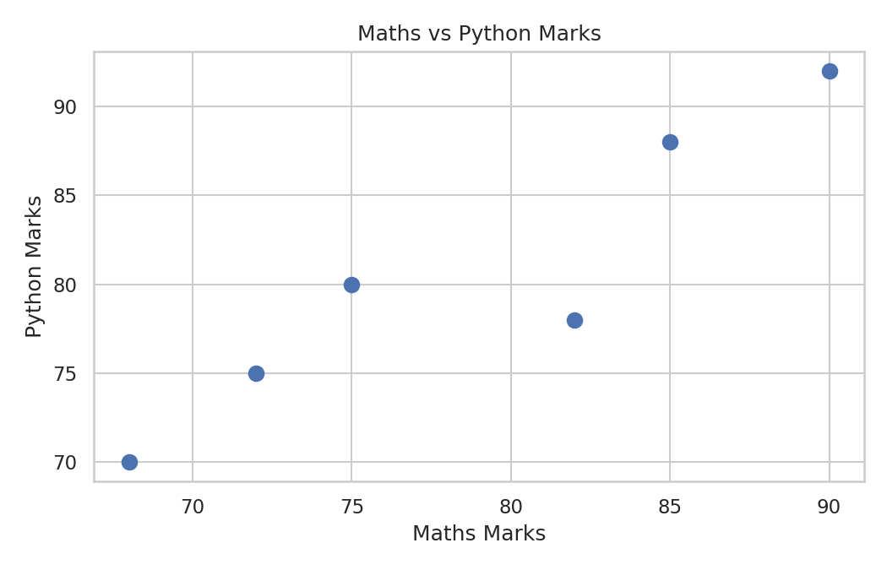
Output – Heatmap:
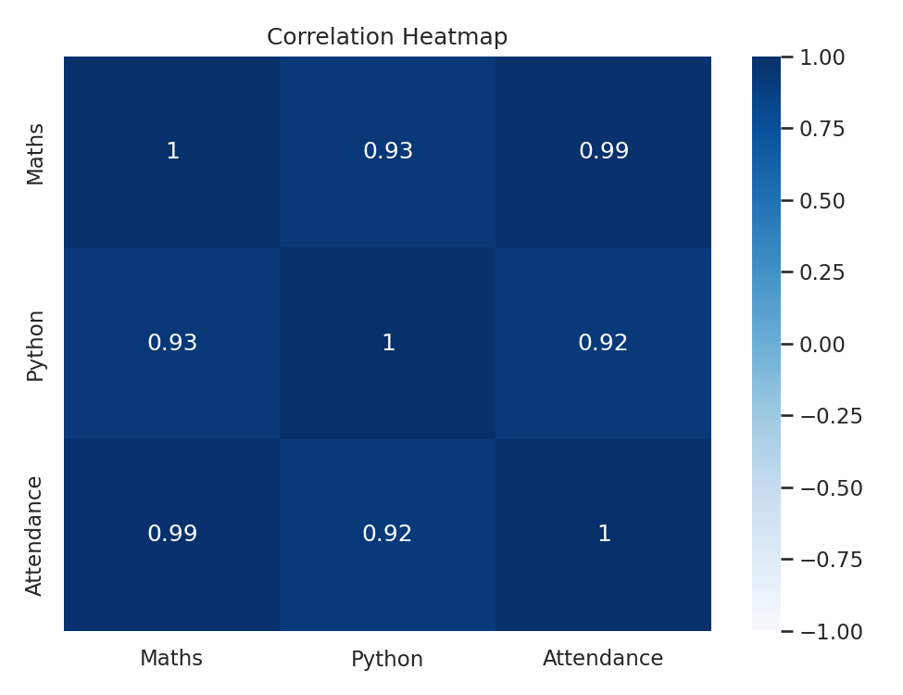
Observations:
• The line plot shows variation in Python marks across students.
• The bar plot allows easy comparison of Maths marks.
• The scatter plot shows the relationship between Maths and Python marks.
• The heatmap shows the correlation values among the numerical attributes.
Conclusion:
The dataset was successfully loaded using Pandas and visualized using Matplotlib and Seaborn. Line, bar, scatter, and heatmap plots were created to understand trends, comparisons, relationships, and correlations in the dataset.
FAQs:
1. Explain the use of plt.plot().
2. What is the purpose of plt.bar()?
3. What information can be obtained from plt.scatter()?
4. What does the correlation matrix represent?
5. Explain the use of sns.heatmap().
6. Why are numerical columns used for correlation?
Prof. Dipali Baviskar

